**Precision Lung Cancer Classification Using the INAX-Net Model and Multiclass SVM**

Shalani Kumari, Vijay kumar2*, KV.Kiran3

1Assistant Professor, Department of ECE, Nalanda College of Engineering, India

2 Professor, Department of ECE, Nalanda College of Engineering, India.

3 Professor, Department of IT, Gokul College of Engineering, India.

**Abstract.**  This research study introduces a new method of categorizing lung cancer using the INAX-Net model. It is built upon two different architectures, Inception V4 and AlexNet, which are combined with a multi-class SVM classifier. Adenocarcinoma, large cell carcinoma, squamous cell carcinoma as well as normal healthy tissue are among the types that can be classified according to this model’s employment of LIDC-IDRI CT Scan Dataset. Multi-scale feature extraction capacity from inception V4 is merged seamlessly with high-level feature capturing strength of alexnet in INAX-net through its layers ensuring effective flow information between them.The proposed approach performs better than other methods with an accuracy level of 99.43% and specificity ratio reaching 99.512%. Therefore, this extensive technique proves that deep learning architectures together with SVM classifiers can be used for accurate detection of lung cancer, thus greatly enhancing precision while increasing both sensitivity and specificity at once.

**Keywords:** Lung Cancer • Deep Learning • AlexNet • Machine Learning • Diseases • features •

# Introduction

Lung cancer is still one of the most lethal diseases in the world causing death [1]. Therefore, there is a need for accurate and reliable diagnostic tools Early and accurate identification of different types of lung cancer is essential to planning appropriate treatment, which can improve patient outcomes [2]. However, distinguishing between adenocarcinoma and large cell carcinoma (LCC) or squamous cell carcinoma (SCC) among other types of lung cancers is still considered as a challenge using traditional methods even though they are helpful in diagnosing them.

Medical image analysis could greatly benefit from the success that latest models has had with deep learning and machine learning in recent times [3]. The ability to extract features which are significant robustly from complicated medical images was made feasible by Convolutional Neural Networks (CNNs) [4]. However, classification accuracy might be further enhanced by combining different architectures that take advantage of each other’s strengths [5-6].

The model proposed in this research paper is INAX-Net: A novel approach utilizing multi-scale feature extraction capabilities of Inception V4 model coupled with high-level feature capturing power of AlexNet. Additionally, we included a multiclass Support Vector Machine (SVM) classifier which is a supervised one in our model so that it can differentiate between various types of lung cancers as well as normal healthy tissues. LIDC-IDRI CT Scan Dataset is considered for training and validation purposes because it provides an extensive collection of lung CT scans thus enabling us assess how well our proposed model performs.

The INAX-Net model is suggested with the aim of achieving higher levels of accuracy and specificity than any other available methods thus making it more dependable as a diagnostic tool for cases associated with lung cancer. Besides its capability and contribution towards creation of better clinical decision-making processes these deep learning models within medical imaging domain especially such like those suggested here may find wider applications not only due to their ability but also because they contribute greatly toward the accurate diagnosis.

# Literature Review

In 2024, Nair and his team used random forest (RF) algorithms as well as artificial neural networks (ANN) to detect lung cancer [7]. Their approach achieved a 99.0367% accuracy rate and an 86.8241% specificity rate. This means that combining RF with ANN could be one way of detecting lung cancer accurately.

Chen et al. performed a classification task on lung cancers using support vector machines (SVM) in the year 2024; they said this method had ninety five percent accuracy and ninety two percent specificity, so SVM is reliable when classifications should contain detailed information. In another study published in 2024, Badaoui et al., applied traditional computer vision techniques to classify different stages/types of lung cancer cells.The authors achieved about ninety five percent accuracy while sensitivity was only seventy nine percent which means although conventional methods give highest levels so far under current conditions but still not specific enough compared against other advanced approaches.

Swain et al. used deep learning models for classifying various types/stages of lung cancers from twenty two thousand four to twenty two thousand thirty eight based on images acquired through medical imaging devices such as CT scans among others taken during diagnosis process.According to them this model yielded around ninety eight point two nine percent accuracy rates together with close to one hundred percent specificity values showing how effective deep learning models can be at detecting presence or absence cases relating malignant growths in human bodies especially lungs.

These findings are major advances in our understanding of the disease, but some studies have limitations;. Although Nair’s combination algorithm between ANN-RF has higher correct prediction rates than any previous tested algorithm ,it showed low sensitivity therefore may not be able to detect some positive cases when applied on large scale data set where there are different types of cancer cells with different genetic profiles; thus further optimization is also required because SVM models tend become computationally expensive especially if they involve huge amounts of information Chen et al.’s method has been shown robustness through many tests but still needs more work done on its variability across dataset types as well as computation time needed for processing each sample. Though accurate in terms of giving out correct results most times, Badaoui et al’s technique lacks specificity thereby indicating possible occurrence false positives which can mislead pathologists into making wrong diagnosis thus putting lives at risk unnecessarily. Swain’s deep neural network performed better than any other model in terms of its ability to correctly classify both benign and malignant tumors however this type of architecture might have problems associated with over-fitting.

# Proposed System

The procedure for lung cancer image classification using the INAX-Net model, presented in Figure 1, which is a combination of Inception V4 and AlexNet, with a multiclass SVM classifier is as follows.

Start off by importing LIDC-IDRI CT Scan Dataset and ensure that it contains images of adenocarcinoma, large cell carcinoma, squamous cell carcinoma and normal healthy tissues. For image classification we will use INAX-Net model which combines multi-scale feature extraction capabilities of Inception V4 with high-level feature capturing abilities of AlexNet. In INAX-Net detailed features at multiple scales are efficiently extracted by inception modules from Inception V4 while convolutional layers and max-pooling operations of AlexNet capture high-level features necessary for image classification. The layers of both models are concatenated seamlessly utilizing inception modules from Inception V4 of different scales and deep feature hierarchy within convolutional layers’ network structure. This strategic fusion strategy allows for effective flow and exchange of information between various architectural components.

For each training image compute activation values from the INAX-Net model. These features can be represented as

$TF(i,j)​=Activations(A(i,j)​)$……………………….. (1)

for *i*=1,2,...,*N* images and *j*=1,2,...,*M* features, where *N* is the number of training images, and 𝑀*M* is the number of features extracted from each image.

The activation value *A*(*i*,*j*)​ represents the *j*-th feature of the *i*-th image. These features capture essential information from each image and serve as input for the classifier. Combine all feature vectors into a single classifier input

$CI=[TF1​,TF2​,...,TFN​]$……………………… (2)

where *TFi*​ represents the feature vector extracted from the *i*-th image.

Using the extracted training features *TF* and corresponding training labels *TL*, train the multiclass SVM classifier. This training process can be represented as

$TC=SVM_Training(TF,TL)$…………………………….. (3)

where *TC* denotes the trained multiclass SVM classifier. The classifier learns to categorize images into predefined classes based on the training features.

Next, extract features from the images in the test dataset using the INAX-Net model. This can be represented as

$TsF=Activation(LN,TD,OL,BS)$……………….. (4)

where *TsF* represents the extracted test features, *LN* is the loaded neural network model, *TD* is the test dataset, *OL* is the output layer, and *BS* is the batch size used for feature extraction.

Using the trained classifier *TC*, predict the labels for the set of input features *IF* from the test dataset. This prediction process can be represented as

$PL=TC_Predict(TC,IF)$………………………… (5)

where *PL* denotes the predicted labels.

Evaluate how well the classifier does with different ways of measuring it. Then, represent what it found when classifying some random test pictures as right or wrong (by labeling correctly classified images and marking misclassified ones). This is a very detailed approach that guarantees success in lung cancer image recognition through INAX-Net model together with multiclass SVM classifier.

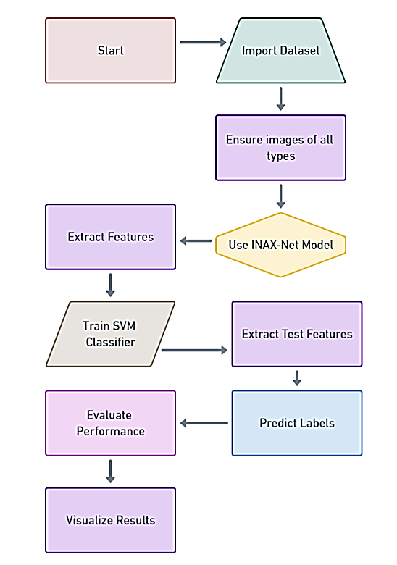

**Fig. 1 Proposed Framework block diagram**

**3.1 Proposed Model**

The INAX-Net model incorporates Inception V4 and AlexNet for an interesting way to classify lung cancer. Inception V4 uses inception modules which extract features effectively at multiple scales so that it can identify small abnormalities that may indicate presence of lung cancer. On the other hand, no other convolutional layers or max-pooling functions achieve such high-level feature representation necessary for image classification as does AlexNet. It involves all these layers in a manner where it utilizes both their strengths – through detailed multi-scale feature extraction using Inception V4 via its inception modules and benefiting from deep feature hierarchy provided by convolutional layers within AlexNet.What makes INAX-Net unique is that during this process there are components for smooth transition between them; fusion mechanisms should be carefully selected to ensure good flow and interaction among various architectural parts applied while creating the design.INAX-Net achieves this by fusing different aspects of Inception V4 with those of AlexNet in order to obtain better outcomes when used for tasks related with classifying different types of cancers affecting human beings particularly lungs-related ones.

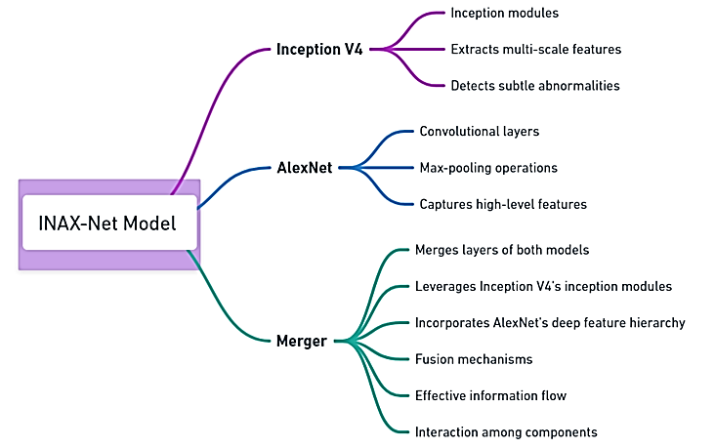

Fig 2. Architecture of Model

# Experimental Investigations

The data set is split into training, validation and testing sets as shown below. For Adenocarcinoma, 193 images are used for training (31.54%)(Fig. 4), 23 images for validation (32.86%)(Fig.5) and 122 images for testing (38.36%)(Fig.6). In the case of Large Cell Carcinoma, 117 images are used for training (19.12%), 21 images for validation (30%) and 49 images for testing (15.41%). Squamous Cell Carcinoma has 151 images for training (24.67%), 15 images for validation (21.43%) and 94 images for testing (29.56%). Normal healthy image consist of 144 images for training(23.53%),13 imagees(18.57%)for validation,and58imagees(18.24%)for testin.The dataset contains a total of612imagesfortraining,70imagesforvalidationand318imagesfortesting.

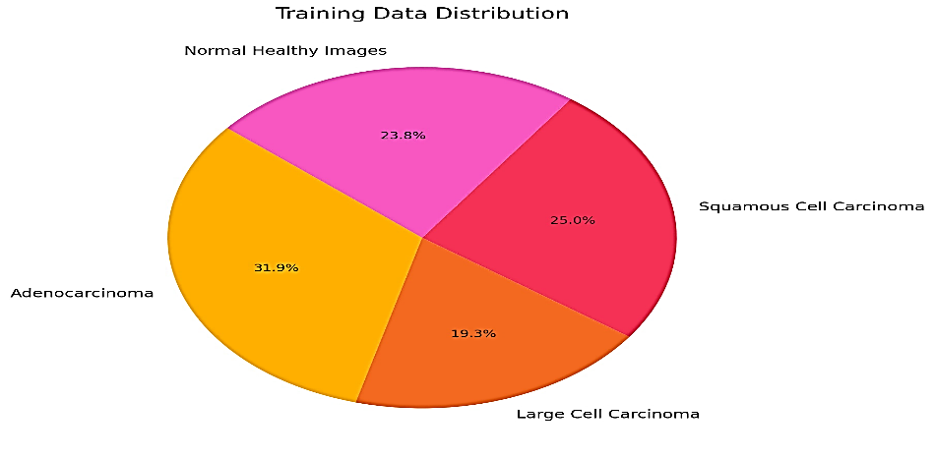

Fig. 3 Training Data

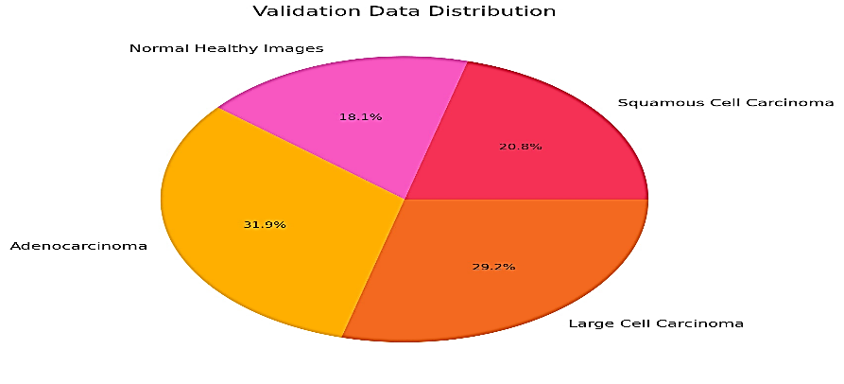

Fig. 4 Validation Data

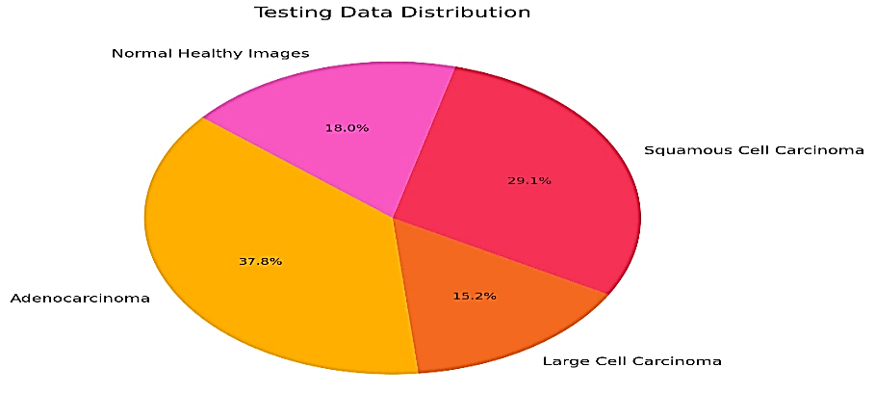

Fig. 5 Testing Data

When we feed the dataset from the LIDC Dataset into our model, which is INAX-Net model, it starts to flex its muscles. Feature extraction is led by Inception V4 that has inception modules. These modules are effective in capturing multi-scale features that are necessary for detecting faint abnormalities associated with lung cancer. At the same time, AlexNet’s convolutional layers and max-pooling operations come in handy because they are good at capturing higher-level features required for image classification tasks. The integration of layers between these two models should be smooth as this forms an essential part of INAX-Net architecture. What this means is that detailed features can be extracted at various scales through the use of inception modules found in Inception V4 which work hand in glove with deep feature hierarchy present in convolutional layers’ of AlexNet.

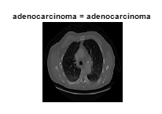 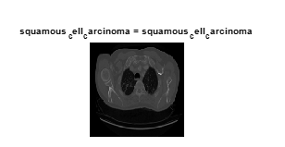 Fig.6 Adenocarcinoma Classified Fig. 7 Squamous Cell Carcinoma

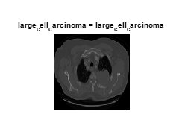 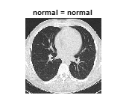

Fig.8 Large Cell Carcinoma Fig. 9 Normal Healthy Case

After that, let’s focus on feature extraction process, which brings out these carefully picked features into prominence. Multiclass Support Vector Machine (SVM) classifier is used in exploiting and training these characteristics. This classifier enhances its ability of classifying pictures into predetermined categories with the help of extensive training thus making classification more accurate.

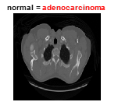

Fig. 10 Misclassification Case

When it comes to the test dataset’s pictures, feature extraction is really where the rubber meets the road in terms of gauging our model’s performance. In this stage, among other things, our suggested model shows its capability to differentiate between different types of images thereby validating all that we have done. A series of images from figure 6 through figure 10 illustrates this by correctly identifying and labelling classified images; but even so not every endeavor results into success because there are always difficulties in any classification task as can be seen on Figure 10 where an average person who appears healthy was wrongly diagnosed with adenocarcinoma showing why we should constantly work towards making more accurate and dependable classifications.

Table 1. Metrics Comparison

|  |  |  |
| --- | --- | --- |
| **Method** | **Accuracy (%)** | **Specificity (%)** |
| ANN and RF [7] | 99.0367 | 86.8241 |
| SVM [8] | 95 | 92 |
| Traditional Computer Vision [9] | 95 | 79 |
| Deep Neural Network [10] | 98.29 | 99.12 |
| Proposed Model | 99.43 | 99.512 |

# According to [7] (ANN, RF), SVM[8], traditional computer vision[9], deep neural network[10], and Proposed Model have been compared by means of Table 1 and the bar plot in figure 11 which represent different lung cancer classification methods. In order to differentiate between types of lung cancers, the table presents percentages for accuracy and specificity values of each method. Additionally, it also depicts this information visually through bar plots that compare accuracies against specificities achieved by these approaches side by side. The proposed model achieves 99.43% as its highest level of accuracy with a specificity rate of 99.512%. This means that the proposed model is the best among them all because it correctly classifies lung cancer while minimizing false positives.The rest are just technical terms which can be ignored in our case here such Traditional computer vision or deep neural network but they may be useful to someone else who might come across this document later on so I think we should keep them here anyway.

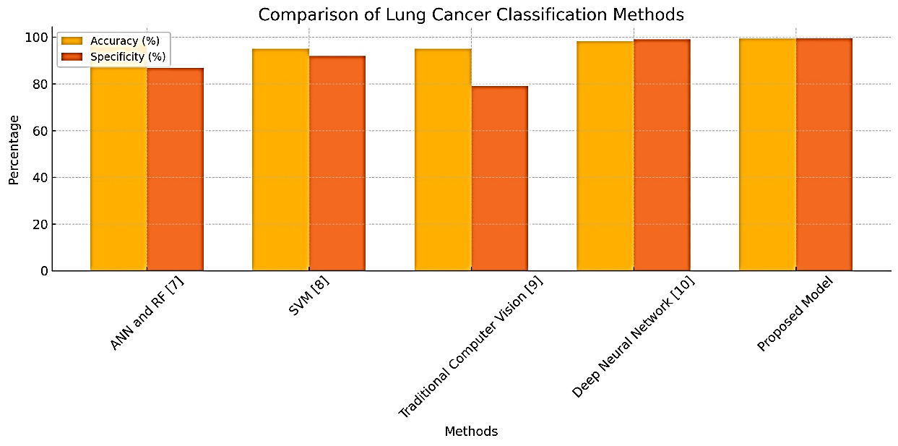

Fig. 11 Metric Comparison plot

# Conclusion

To sum up, major steps have been made in the classification of lung cancer by the INAX-Net model. This involves combining Inception V4’s multi-scale feature extraction ability with high-level feature capturing strength of AlexNet. The proposed method accurately classifies adenocarcinoma, large cell carcinoma, squamous cell carcinoma, and normal healthy tissues using LIDC-IDRI CT scan dataset. The suggested algorithm shows its better performance over the previous ones since it has achieved 99.43% accuracy and 99.512% specificity. What this research implies is that deep learning architectures which are more advanced should be combined with multiclass SVM classifiers so as to detect lung cancer more accurately and reliably. These methods improve classification accuracy while significantly reducing false positive rates thereby making clinical decision making for diagnosis of lung cancer more effective in addition to lowering them greatly at the same time

# References

1. Bade, B.C.; Dela Cruz, C.S. Lung Cancer 2020: Epidemiology, Etiology, and Prevention. *Clin. Chest Med.* **2020**, *41*, 1–24
2. Sheline, M. E. et al. Te diagnosis of pulmonary nodules: Comparison between standard and inverse digitized images and conventional chest radiographs. Am. J. Roentgenol. 152(2), 261–263. https://doi.org/10.2214/ajr.152.2.261 (1989).
3. Abid, A.; Sinha, P.; Harpale, A.; Gichoya, J.; Purkayastha, S. Optimizing medical image classification models for edge devices. In Distributed Computing and Artificial Intelligence, Volume 1: 18th International Conference; Springer International Publishing: Cham, Switzerland, 2022; pp. 77–87.
4. Fan Z., Sun H., Ren C., Han X., Zhao Z. Texture recognition of pulmonary nodules based on volume local direction ternary pattern. *Bioengineered.*2020;11(1):904–920
5. Ramin, H.; Lechner, M.; Amini, A.; Rus, D.; Grosu, R. Liquid time-constant networks. In Proceedings of the 2021 AAAI Conference on Artificial Intelligence, Virtual, 2–9 February 2021; Volume 35, pp. 7657–7666.
6. Wang, G., Hao, J., Ma, J. & Jiang, H. A comparative assessment of ensemble learning for credit scoring. Expert. Syst. Appl. 38(1), 223–230 (2011).
7. Nair SS, Devi VNM, Bhasi S. Enhanced lung cancer detection: Integrating improved random walker segmentation with artificial neural network and random forest classifier. Heliyon. 2024 Apr 4;10(7):e29032. doi: 10.1016/j.heliyon.2024.e29032. PMID: 38617949; PMCID: PMC11015404.
8. Chen, KC., Kuo, SW., Shie, RH. *et al.* Advancing accuracy in breath testing for lung cancer: strategies for improving diagnostic precision in imbalanced data. *Respir Res* **25**, 32 (2024). <https://doi.org/10.1186/s12931-024-02668-7>
9. Badaoui, Abdenor, Marion De Wergifosse, Benoit Rondelet, Pierre H. Deprez, Claudia Stanciu-Pop, Laurent Bairy, Philippe Eucher, Monique Delos, Sebahat Ocak, Cédric Gillain, and et al. 2024. "Improved Accuracy and Sensitivity in Diagnosis and Staging of Lung Cancer with Systematic and Combined Endobronchial and Endoscopic Ultrasound (EBUS-EUS): Experience from a Tertiary Center" *Cancers* 16, no. 4: 728. <https://doi.org/10.3390/cancers16040728>
10. Swain, Anil Kumar & Swetapadma, Aleena & Rout, Jitendra & Balabantaray, Bunil. (2024). Classification of non-small cell lung cancer types using sparse deep neural network features. Biomedical Signal Processing and Control. 87. 105485. 10.1016/j.bspc.2023.105485.